# Target Metrics

Overall - Accuracy: 0.8000, Precision: 0.8492, Recall: 0.8000, F1: 0.8027

Class-specific metrics:

Carbon neutral(ity) - Precision: 0.8824, Recall: 0.6000, F1: 0.7143

Emissions reduction target - Precision: 0.9048, Recall: 0.7600, F1: 0.8261

Net zero - Precision: 0.6098, Recall: 1.0000, F1: 0.7576

No target - Precision: 1.0000, Recall: 0.8400, F1: 0.9130

# Year Metrics

Overall - Accuracy: 0.8700, Precision: 0.8746, Recall: 0.8700, F1: 0.8690

Class-specific metrics:

2020 - Precision: 0.0000, Recall: 0.0000, F1: 0.0000

2022 - Precision: 0.0000, Recall: 0.0000, F1: 0.0000

2025 - Precision: 1.0000, Recall: 0.6000, F1: 0.7500

2030 - Precision: 0.8462, Recall: 0.8800, F1: 0.8627

2031 - Precision: 0.0000, Recall: 0.0000, F1: 0.0000

2031-32 - Precision: 0.0000, Recall: 0.0000, F1: 0.0000

2032 - Precision: 0.0000, Recall: 0.0000, F1: 0.0000

2033 - Precision: 0.0000, Recall: 0.0000, F1: 0.0000

2035 - Precision: 0.8333, Recall: 1.0000, F1: 0.9091

2040 - Precision: 1.0000, Recall: 0.9000, F1: 0.9474

2050 - Precision: 0.8571, Recall: 0.8889, F1: 0.8727

No target - Precision: 0.9600, Recall: 0.9600, F1: 0.9600

# Other Metrics

Quote Accuracy: 0.6900

Overall Accuracy: 0.7500

Valid XML Percentage: 1.0000

# Confusion Matrices

Target Confusion Matrix:

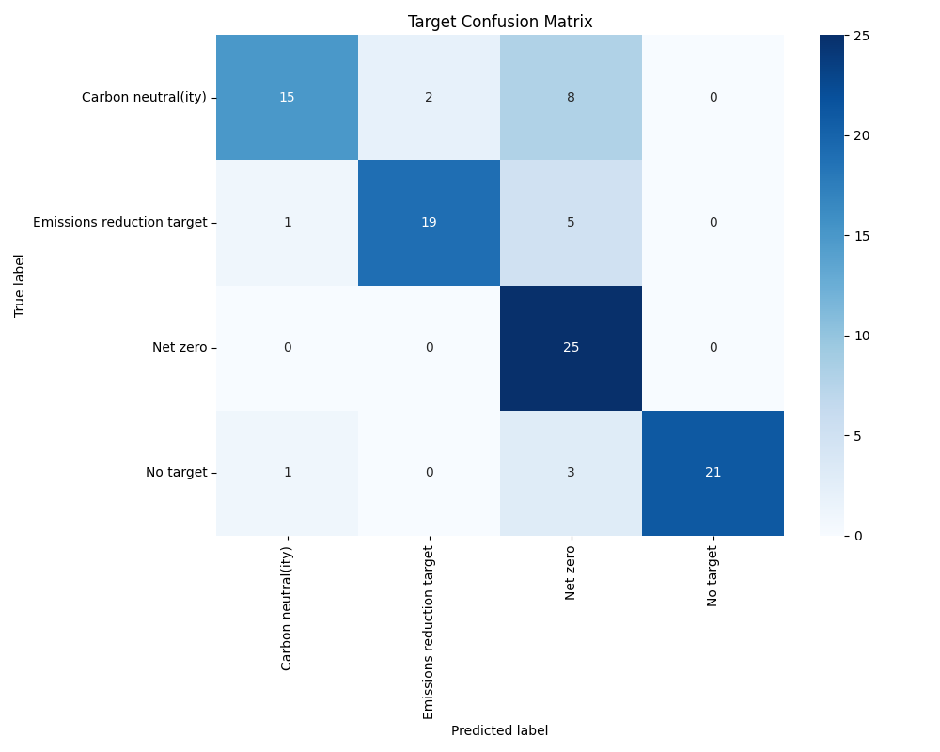

Year Confusion Matrix:

